**Abstract Black Floral Pattern Backlit Metal Wall Art**

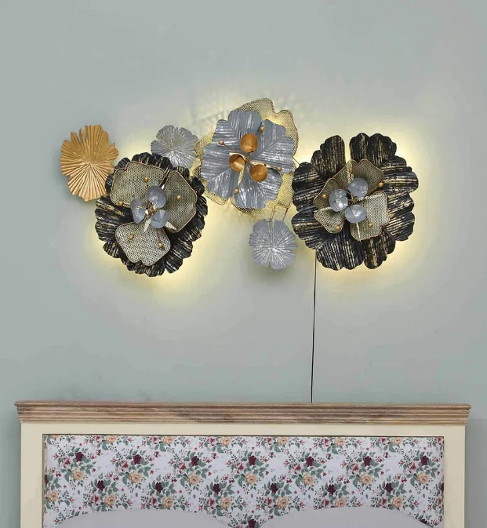Abstract black floral pattern backlit metal wall art is a striking fusion of modern design and artistic sophistication. The piece features intricate, abstract floral patterns crafted in sleek black metal, offering a bold, contemporary aesthetic. What sets it apart is the subtle backlighting that illuminates the design from behind, creating a dramatic, glowing effect that adds depth and intrigue to the artwork. Ideal for contemporary living rooms, bedrooms, or hallways, this backlit art piece not only serves as a captivating focal point but also enhances the ambiance of any space, combining form and function with a touch of luxury.